 |  |  |  | 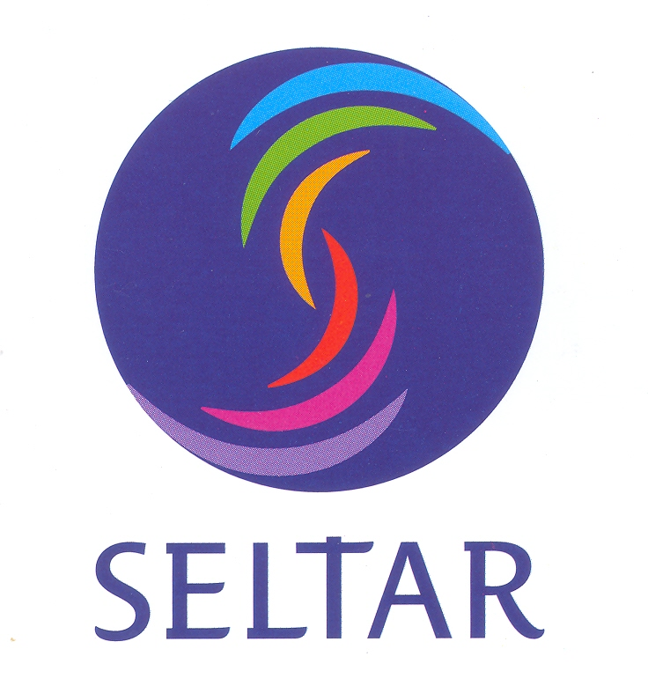
 | APPLICATION FORM

Collective training on measuring water flows and balances within the “critical zone" of tropical argo-ecosystems of South East Asia

28th October – 1st November, 2013,
Luang Prabang, Lao PDR
First Name: Last Name:
Gender: Mr. Mrs. Ms.
Nationality:

Date and Place of Birth:
Current position (PhD, Postdoc, position at university, etc…):
Name of Institution:
Office address:
E-Mail Address:
Telephone number (Include country and city code):
Self evaluation of English Proficiency
Understanding |  | Speaking | Writing
Listening | Reading | Speaking | Writing
Instructions for using the self-assessment grid
The grid consists of three broad levels as follows:
- Level 1: Basic user (I can understand familiar words and very basic phrases concerning myself, my family and immediate surroundings when people speak slowly and clearly. I can speak, read and write such familiar words/phrases)
- Level 2: Advanced user (I can understand the main points of clear standard speech on familiar matters regularly encountered in work, school, leisure, etc. I can speak, read and write such standard words/phrases).
- Levels 3: Proficient user (I have no difficulty in understanding any kind of spoken language, whether live or broadcast, even when delivered at fast native speed. I can fluently speak, read and write elaborated phrases)
Academic degrees
- Recent (last) degree received and Major:

Name of Academic Institution and Date:
- Current (expected) degree (for PhD students):

Name of Academic Institution and Date:

Motivation:

Please specify why you want to attend this training course. In particular, specify the framework in which you will use the field techniques taught during the training.

(1 page max. with 11 pt font)

