 |  |  |  |  |  | 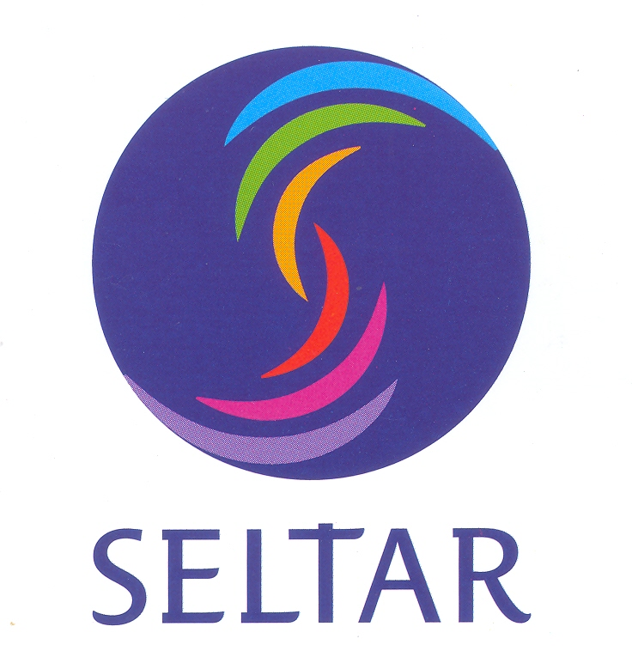 |  | 
APPLICATION FORM

Workshop on writing scientific articles in English for international journals in the domain of environmental and agricultural science
30th September to 4th October, 2013, Khon Kaen University, Thailand

First Name: Last Name:
Gender:
Nationality:

Date and Place of Birth:
Current position
Type (PhD, Postdoc, position at university …etc):

Starting and ending (if applicable) dates:
Name of Institution:
Office e-Mail Address: Personal e-Mail address
Office address:
Telephone number (Include country and city code):

Self evaluation of English Proficiency
Self-assessment |  | Understanding |  |  |  | Speaking |  |  |  | Writing
level |  | Listening |  | Reading |  | Spoken interaction |  | Spoken production
English

Instructions for using the self-assessment grid
The grid consists of three broad levels as follows: Basic user (levels A1 and A2); Independent user (levels B1 and B2); Proficient user (levels C1 and C2).

To self-assess your foreign language level, read the descriptions below and write the relevant level (e.g. Proficient user - C2) in the adequate box of your CV (Listening, Reading, Spoken interaction, Spoken production and Writing).
For more information please follow the link below:
http://europass.cedefop.europa.eu/img/dynamic/c1345/type.FileContent.file/CVInstructions_en_GB.pdf

Academic degrees
- Recent (last) degree received and Major:

Name of Academic Institution and Date:

- Current (expected) degree (for PhD students):

Name of Academic Institution and Date:

Research experience (Nature of the work and responsibilities. Please specify the employers, name of the institutions, employment dates, research topics…). (1 page max with 11 pt font double spaced)

Please tell us where you heard of this training course: ___________________

